
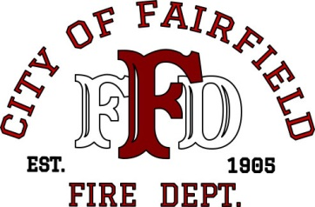

MEMORANDUM

FAIRFIELD FIRE DEPARTMENT

DATE: Current Date

TO: Current CM, Title
Current Assistant CM, Title
Current Police Chief, Title
Current Fire Chief, Title
Current DC, Title
Current DC, Title

FROM: Name, Title (note: if from a DC, remove name above)

SUBJECT: Structure Fire

On DATE (i.e. March 4, 2015) at TIME (i.e.1541 hours), TYPE NARRATIVE (i.e. a report of a vehicle fire in a carport at 814 Broadway Street was called in with a structure threatened. Battalion 37 requested Dispatch to call in Suisun District because the fire was in an auto aid area. Upon Suisun District’s arrival, they reported a working fire in a carport. Engine 37 arrived on scene. Battalion 37 took command upon arrival on scene and had all incoming units staged, Engines 40 and 41. Engine 39 was diverted to a medical call at 1027 Oliver Road. Engine 35 was moved to Abernathy Road for City coverage.

The fire was knocked down and there were no injuries. The fire was contained to the vehicle and carport area.

If you know the amount of damage in dollars and to what area(s), you can include that information as well as any assistance that the homeowner(s), renter(s), visitor(s) needed or were offered. Also, give credit to any outside agencies that responded.

NOTE: Narrative above is sample only. Areas highlighted must be included, if applicable. Remember to remove highlight from all text and delete any sample notations.

If you have any questions, please contact me.

Initials of person writing memo, i.e. JM

