
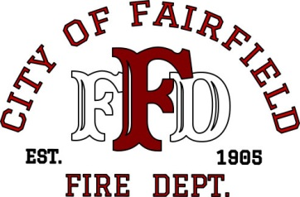

MEMORANDUM

FAIRFIELD FIRE DEPARTMENT

DATE: Current Date

TO: Current CM, Title (ie. David A. White, City Manager)
Current Assistant CM, Title (ie. Laura Snideman, Assistant City Manager)
Current Police Chief, Title (i.e. Joe Allio, Police Chief)
Current Fire Chief, Title (i.e. Tony Velasquez, Fire Chief)
Current DC, Title (i.e. Jorge Merodio, Deputy Chief)
Current DC, Title (i.e. Steve Trepagnier, Deputy Chief)

FROM: Name, Title (note: if from a DC, remove name above)

SUBJECT: TYPE OF ACCIDENT (i.e. Motor Vehicle Accident)

On DATE (i.e. March 4, 2015) at TIME (i.e.1541 hours), TYPE NARRATIVE (i.e. Fairfield Dispatch received a report of a major injury accident westbound I-80, east of the 680 off ramp. Engine 40 arrived to find a single vehicle into a tree with two patients. One of the patients required extrication in order to be removed from the vehicle. Truck 37, Engine 41 and Battalion 37 responded to the accident to assist Engine 40 with patient care and extrication.

Medic Ambulance transported both patients to NorthBay Medical Center with Engine 40’s Firefighter/Paramedic; their injuries were not life threatening.

If you know the amount of damage in dollars and to what area(s), you can include that information as well as any assistance that the homeowner(s), renter(s), visitor(s) needed or were offered. Also, give credit to any outside agencies that responded.

NOTE: Narrative above is sample only. Areas highlighted must be included, if applicable. Remember to remove highlight from all text and delete any sample notations.

If you have any questions, please contact me.

Initials of person writing memo, i.e. JM

